 | 

Anniversary offer on Sennheiser’s Memory Mic
A perfect companion for video creation – get better audio with an external mic

Marlow/UK, 7 April 2020 – In view of the current situation, audio specialist Sennheiser has added another special deal for the month of April and is now offering its wireless Memory Mic for just EUR99 (MSRP, reduced from EUR199). The Memory Mic and its free companion app make it easy to create smartphone videos with great audio and are ideal for course instructors and vloggers but also families keen to stay in touch. Visit the Sennheiser Online Shop or www.sennheiser.com/special-deals to secure this special offer for yourself. The reduced price will be available until 31 May 2020 while stocks last.

Recent weeks have seen a vast degree of face-to-face communication being transferred to the digital realm: from the yoga instructor who now needs to produce video lessons to stay in touch with students, to the musician posting spontaneous music videos from home on social media, or the families lovingly creating video messages to grandparents.

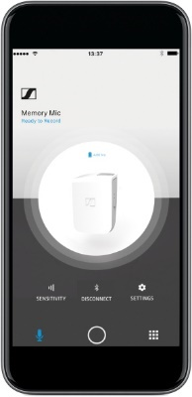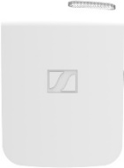 | The wireless Memory Mic is used with a free companion app, to let you create smartphone videos with great audio. The Memory Mic is simply attached to the clothing with its magnetic clip.

Good audio from an external microphone makes videos like these into something special, creating just the right atmosphere and adding that professional touch. That’s why Sennheiser is now offering its smartphone solution Memory Mic for just half the price.

The Memory Mic links up with the MEMORY MIC smartphone app (available free of charge from Google Play or Apple Store) via Bluetooth and works wirelessly at any distance from the smartphone to give you plenty of creative freedom in making your video. Then simply synchronise audio and video via the app at the touch of a button. The app additionally includes a mixing function which enables you to intuitively select a good mix between the sound of the Memory Mic and the ambient sound recorded by your smartphone.

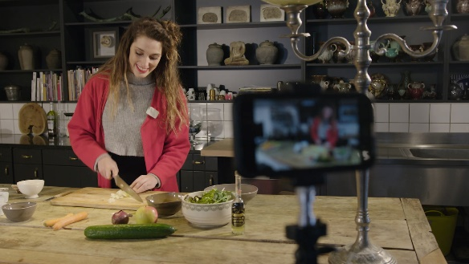  Record yourself with the Memory Mic… | 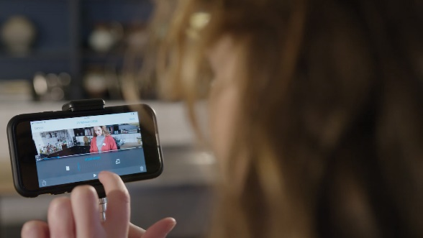  …then select an ideal mix between your voice and the ambient sound.

Via the app, you can also adjust the audio level of the microphone, which is very helpful for picking up soft voices. As the Memory Mic is wireless, it does not occupy any input on the smartphone, therefore you can still employ additional accessories if desired.

The Memory Mic is reliable, robust and very forgiving when the distance and direction you talk from varies. Its operating time amounts to up to four hours, then it can simply be recharged via its USB connector. After an hour, the battery will have already reached 70% of its full capacity and the microphone is ready for recording the next video.

Special offers throughout Sennheiser’s 75th anniversary year
In its anniversary year, Sennheiser will be offering incredible savings on selected wired microphones, wireless systems and headphones. To stay informed about the latest offers, make sure to take a regular look at the campaign website www.sennheiser.com/special-deals to discover new promotions every month.

The images accompanying this press release can be downloaded at https://sennheiser-brandzone.com/c/181/zZLDqXUZ.

About Sennheiser
Founded in 1945, Sennheiser is celebrating its 75th anniversary this year. Shaping the future of audio and creating unique sound experiences for customers – this aim unites Sennheiser employees and partners worldwide. The independent family company, which is managed in the third generation by Dr. Andreas Sennheiser and Daniel Sennheiser, is today one of the world’s leading manufacturers of headphones, loudspeakers, microphones and wireless transmission systems. In 2018, the Sennheiser Group generated turnover totaling €710.7 million. www.sennheiser.com

Global Press Contact

Stephanie Schmidt
Stephanie.schmidt@sennheiser.com
+49 (5130) 600 – 1275

Local Press Contacts

Sarah James Maik Robbe
sarahj@gasolinemedia.com maik.robbe@sennheiser.com
+44 (0) 1483 223333 +44 (0) 7393 462484

